Supervision Plan

- A ratio of at least 1 adult to 10 children is always maintained.
- The preschool is securely fenced and gated and families enter through a double self-closing gate.
- Families and children are greeted on arrival and departure to ensure children are safe and well arriving and leaving.
- The teacher ensures all children are signed in by a responsible adult, takes a head count of children by 9:20am, checks the paper roll and Passtab data match and marks the roll on School Bytes.
- Preschool educators always maintain active supervision of all children. When educators supervise children, they do not perform other duties that would affect the quality of their supervision and their interactions with children.
- Educators inform each other before leaving any area where children are present and ensure adequate supervision is always maintained. They ensure educators acknowledge what they have said before they leave.
- Preschool educators are aware of potential hazards to ensure the risk of illness, accidents and harm is reduced wherever possible, detected through the daily safety check and risk management processes.
- Educators take a common-sense approach to ensure children are adequately supervised based on their visibility and the accessibility of areas in the preschool e.g. toilets.
- Educators ensure they can respond to children immediately, particularly if a child is distressed or in an unsafe situation.
- Educators know where children are at all times by actively and diligently monitoring their activities.
- Water play activities are monitored more closely with the educator standing near the children and water. Water is emptied when play ceases.
- Opportunities for risky play are considered in the playground and are provided in a way that allows close supervision, e.g. water play and the hammer and nails activities are not offered at the same time, as they both need close adult supervision.
- Students who become unwell are made comfortable in the area adjacent to the preschool office. This may involve moving play from the outdoor to the indoor play areas and seeking assistance from the school office to have extra staff available in the preschool to assist with supervision.
- If a child is sleeping, educators maintain close supervision and record the length of sleep, and when checks were made within the sleep log. Where needed, the program may be moved indoors if this is required to maintain supervision of the sleeping child/ren and the other children.
- Educators balance supervision and engagement by drawing on a range of skills such as positioning, using peripheral vision and monitoring changes in noise and stress levels.
- When visiting the main school or attending excursions, the teacher takes a head count of children before leaving the preschool, on arrival and departure from the destination and upon return to the preschool.
- Teachers are relieved for lunch and/or recess by a teacher from the school as per the weekly duty roster.
- SLSOs are relieved for a lunch and recess break by a suitably qualified SLSO or teacher from the school.
- Full-time teachers receive at least two hours of release from face-to-face teaching per week and are replaced by a teacher from the school as per the school timetable.
- School leadership teams monitor processes and procedures in the preschool to ensure children are adequately supervised and safe.
- We recognise that some children have additional toileting and sensory needs. When required, two educators may be required to support toileting needs indoors. In this instance, two educators come inside, and one educator supervises outdoors from the central outdoor supervision point, as marked by the blue star. If this is expected to take more than a few minutes, additional support is sought by calling the office. Some children may not follow the routine of indoor and outdoor play due to their sensory needs. In these circumstances, one educator supervises the child from a space where they can maintain supervision of the child and can also be seen by other educators. Accommodations for individual children are outlined in their personalised risk assessment plans, or individual education plans.
- Trial – preschool educators will trial using radios to communicate with each other during outdoor play. This will support communication when an educator has come inside to assist a child who has visited the bathroom.

Morning drop-off procedures:
- One educator inside to ensure families are signing children in correctly using the iPad, and supervising children while they store their bags and prepare for the day.
- During the summer timetable, one educator positioned at the sunscreen station to assist children in applying sunscreen and monitoring the entrance gates to ensure no preschool children leave. During the winter timetable, this educator also assists at the sign-in area and monitors the door to ensure children do not go back outside. This educator also marks off the paper attendance roll as the children come through the gate.
- One educator engaging with the bulk of the children in the play spaces, supporting them to engage in play and settle in for the day.
Afternoon pick-up procedures:
- One educator monitoring the sign-out area to ensure families sign out correctly using the iPad, and that only authorised collectors are collecting the children.
- One educator leading the learning experiences for the bulk of children.
- One educator works flexibly between the group of children and the sign-in area, depending on where it is busier. This includes supporting children who are excited to see families arriving and may run outside looking for their parents.

Supervision Plan – Outdoor Environment
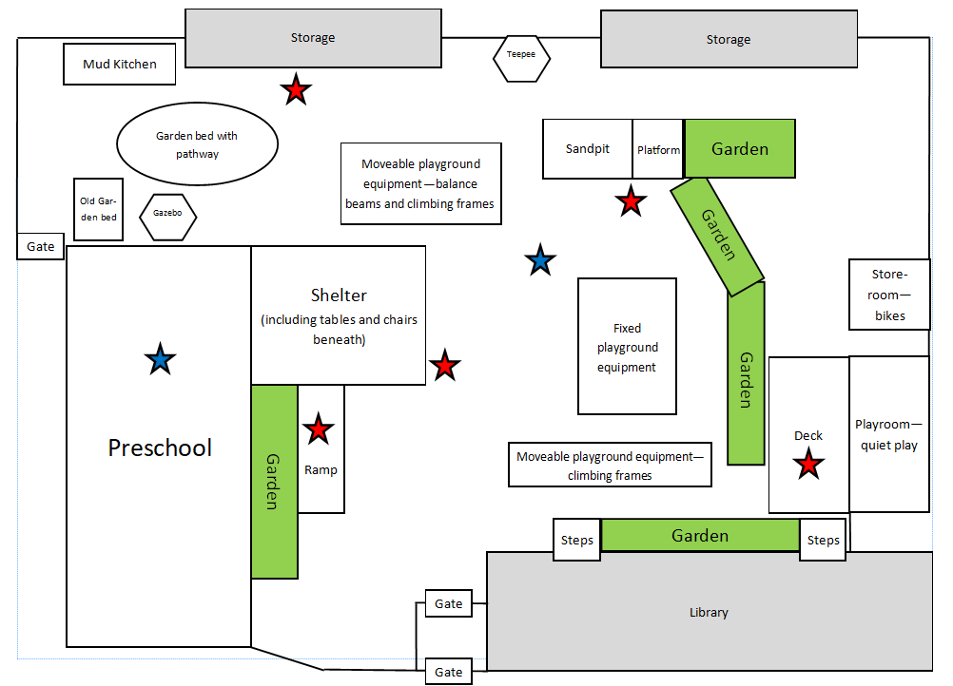
Markings:
- The red stars indicate key supervision points. Educators need to be aware of the movement and play patterns of the children and select a supervision point accordingly, ensuring that each educator is positioned separately to provide coverage of the whole playground.
- If a child needs to access the bathroom, one educator positions themselves on the ramp to maintain supervision of the child in the preschool while also assisting supervision of the outdoor area. All educators need to be aware that a child is indoors so that supervision points can be modified while one staff member is on the ramp.
- If the staff member needs to go into the preschool building to assist the child (blue star), they must ensure the other staff member is aware, and the educator working outdoors should supervise from the outdoor point marked with the other blue star.

Educators:
- Display awareness– monitor children actively and diligently
- Are aware of positioning – all children must be within sight or sound
- Scan areas where children are playing, assessing visibility and accessibility
- Redirect children to other areas/activities when undesirable behaviours occur
- Ensure adequate supervision based on risks in the environment and experiences provided
- Implement quality interactions
- Do not perform other duties while responsible for the supervision of children
- Are aware of the importance of communicating with each other about their location within the environment
- Throughout each duty, educators discuss adequate supervision and ensure each educator is spaced in a way that supervision of the whole preschool playground occurs, based on the play patterns that day.

